CondorIntelligence: Rapid Evolution of an Institutional-Grade Neural Options Trading System
Period Covered: January 6 – January 13, 2026
System: CondorIntelligence (Quantor‑MTFuzz / Gaussian Options Platform)
Author/Developer: Dr. T. Jerry Mahabub, Ph.D.

Abstract
This paper presents CondorIntelligence™, an institutional-grade advanced, computationally intensive, AI-neural options trading system developed as part of the Quantor-MTFuzz™ framework, and documents an unusually high-velocity, one-week architectural transformation (January 6–13, 2026). The intended audience is neural network software engineers, sophisticated FinTech investors/treaders, and quantitative system designers building / day-trading automated trading systems who require a realistic, end-to-end benchmark for evaluating trade sizing, probability of success, regime awareness, and execution robustness.
Rather than focusing solely on predictive accuracy, CondorIntelligence is engineered as a decision-calibrated intelligence system: neural forecasts are explicitly constrained, validated, and transformed into executable trades through lag-aware data alignment, multi-objective learning, neural–fuzzy fusion, and institutional risk controls. The system is designed to function as a reference architecture against which other learning-based trading systems can be compared, stress-tested, and improved.
Recently, it is starting to morph into the next-gen real-time AINN technology which is second to none on the market today.

1. Introduction
Automated trading systems built on neural networks often fail not because of poor prediction accuracy, but because of misalignment between model outputs and real-world trading constraints. Engineers designing such systems must reconcile:
- Noisy, lagged, and asynchronous market data
- Non-stationary volatility regimes
- Path-dependent risk and capital constraints
- The gap between probabilistic forecasts and executable trades
Most open-source and academic trading models address these concerns only partially, focusing on price prediction or signal generation in isolation, focusing on a max of up to 1 million parameters in real-time for learning and validation to construct a model. First of its kind, ComndorIntelligence, learns and constructs highly advanced neural models on > 200 million parameters concurrently and in real-time.
“Quantor-MTFuzz—and specifically its CondorIntelligence engine—has been designed to serve a different purpose: an institutional-grade benchmark system that demonstrates how neural networks can be responsibly integrated into a full trading decision pipeline.”
The goal of this work is not to claim optimal performance, but to provide a reference implementation that shows:
- How to structure a linear-time neural temporal backbone suitable for market data
- How to jointly train policy, regime, and horizon objectives
- How to transform neural outputs into calibrated trade size and probability of success predictions
- How to enforce causality, alignment, and risk discipline end-to-end
This paper documents a concentrated one-week effort in which CondorIntelligence was elevated from a research prototype, first developed in 2018, then shelved for > 7 years, into its very recent rebirth, a system suitable for use as a comparative baseline by other neural trading practitioners.

2. System Overview
At a high level, CondorIntelligence consists of six tightly integrated layers:
- Real‑time, lag‑aware data harvesting
- Deep Mamba‑2 neural intelligence engine
- Mixture‑of‑Experts regime modeling
- Neural‑fuzzy decision fusion
- Institutional risk and sizing
- Precision execution and post‑trade analytics
Figure 1 (System Overview) provides a condensed architectural map of the complete pipeline, from CSV ingestion through live trade execution and performance attribution.

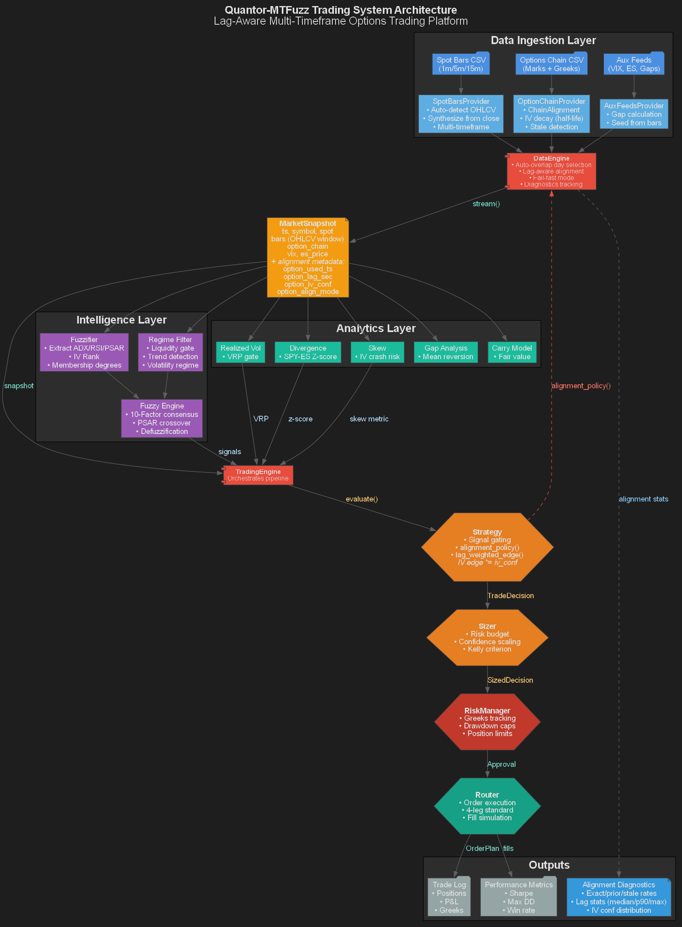

3. Data Engineering and Lag‑Aware Alignment

3.1 Multi‑Timeframe Market Ingestion
The data layer ingests synchronized spot and derivatives information across multiple granularities:
- 1‑minute, 5‑minute, and 15‑minute SPY bars
- Full option chain snapshots with Greeks
- Auxiliary volatility feeds (VIX, IV term structure, gaps)
All raw data is memory‑mapped and accessed via zero‑copy tensor views, enabling O(1) random access without CPU materialization.

3.2 Lag‑Aware Options Alignment
A central innovation is the Lag‑Aware Timestamp Alignment Pipeline (Figure 2). Rather than assuming synchronous spot and options data, the system:
- Detects exact vs. prior chain matches
- Computes lag in seconds
- Applies an exponential IV confidence decay
- Enforces policy‑dependent cutoffs (decay‑only, decay‑then‑cutoff, hard cutoff)
This mechanism eliminates look‑ahead bias while preserving usable signal in imperfect real‑world data.

4. Deep Mamba‑2 Neural Engine

4.1 Architectural Motivation
Mamba‑2 was selected to address three constraints simultaneously:
- Linear time complexity over long horizons
- Strong inductive bias for temporal systems
- Efficient GPU execution via fused selective scan kernels

4.2 Core Design
The neural backbone consists of 24 stacked Mamba‑2 layers, each implementing:
- RMSNorm pre‑conditioning
- Local convolutional context (Conv1D)
- Continuous‑to‑discrete SSM dynamics via Zero‑Order Hold (ZOH)
- Fused CUDA selective scan (O(N))
- Multiplicative gating for non‑linear control
Figure 3 (Mamba Engine Logic) illustrates the internal state evolution, gating path, and expert decoding interface.
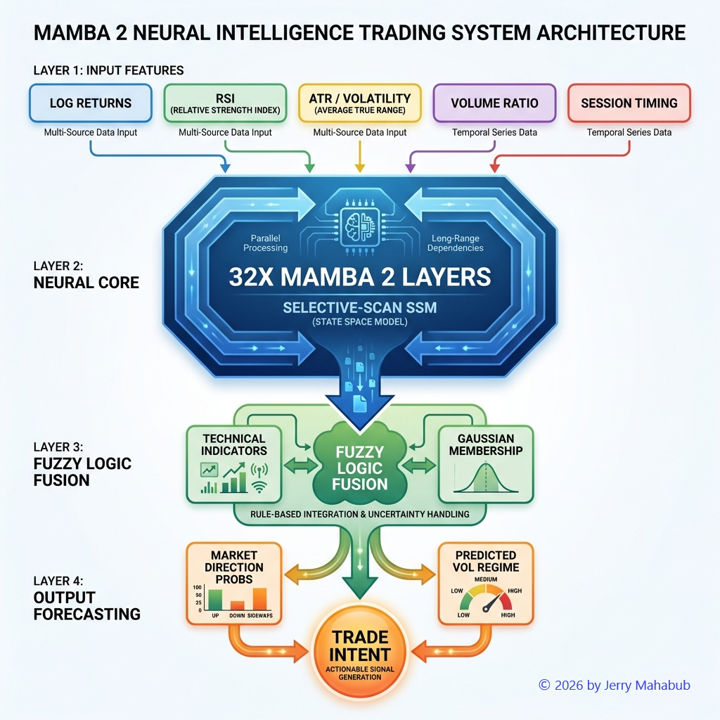

4.3 Precision and Throughput
Training and inference are performed in BF16 mixed precision, optimized for A100/H100 Tensor Cores. CUDA graph capture and GPU‑resident data streaming eliminate host‑device synchronization bottlenecks, resulting in a substantial increase in iterations per second.

5. Multi‑Channel Intelligence and Learning Objectives

5.1 23‑Head Joint Output Space
The model produces 23 coordinated outputs, grouped into three families:
- Policy Heads (8): Iron condor parameters (offsets, widths, DTE, POP, ROI)
- Regime Experts (3): Low, Normal, High volatility gating
- Horizon Forecasts (12): 1‑, 3‑, 5‑, and 10‑day price trajectory statistics
This design forces the shared latent state to encode information useful across trading, forecasting, and regime detection.

5.2 CondorLoss: Multi‑Objective Optimization
Training is governed by a Lagrangian composite loss combining:
- Huberized regression loss
- Cross‑entropy regime classification
- Horizon forecast MSE
Temporal cross‑validation is performed without shuffling, preserving causality.

6. Neural‑Fuzzy Fusion and Risk Intelligence
Neural outputs are passed to an 11‑factor Fuzzy Inference System (FIS), which serves as a symbolic safety and alignment layer.
Inputs include:
- Multi‑timeframe consensus
- IV rank and volatility regime
- RSI, ADX, Bollinger Bands, PSAR
- Volume and price‑position metrics
Membership functions convert raw signals into interpretable degrees (low / medium / high), enabling deterministic reasoning under uncertainty.
Figure 4 (Fuzzy Position Sizing Pipeline) details how fuzzy confidence interacts with volatility dampening to produce a final position size.
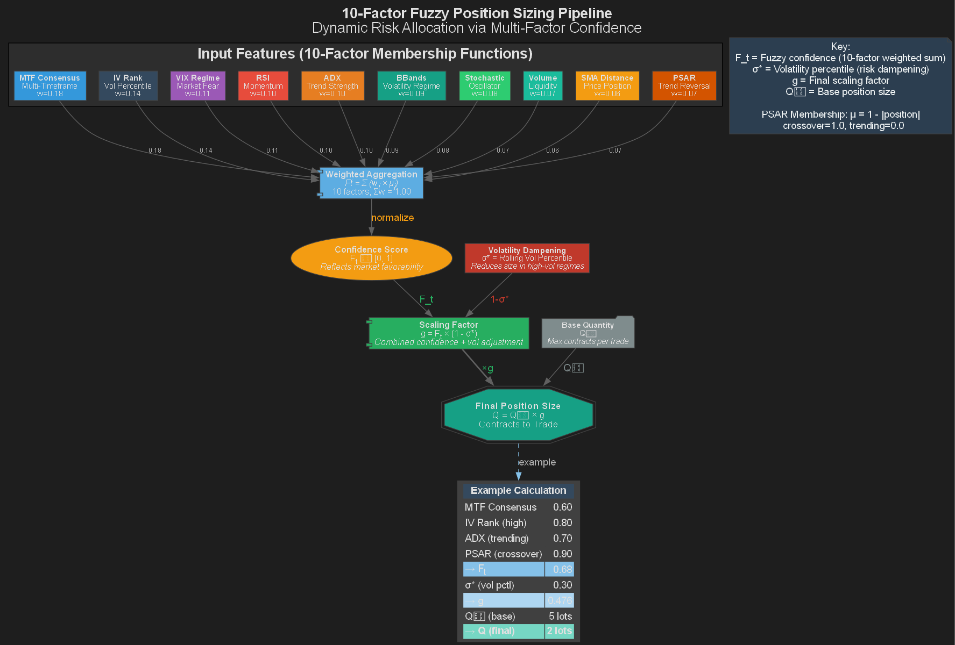

7. Institutional Risk, Sizing, and Execution

7.1 Dynamic Risk Allocation
Position sizing is computed as:
- Fuzzy confidence score
- Volatility percentile dampening
- Risk‑budget‑constrained base quantity
This ensures exposure is automatically reduced during unstable regimes while remaining aggressive when signals align.

7.2 Precision Execution
Trades are executed via a dedicated execution stack:
- Four‑leg iron condor selection
- Smart order routing (TWAP / limit / market)
- Broker abstraction layer (IBKR / TDA / simulator)
Figure 5 (Institutional Execution Flow) shows the full lifecycle from intent to fill acknowledgment.

8. Monitoring, Visualization, and Scientific Evidence
To ensure the system is usable as a benchmark rather than a black box, CondorIntelligence incorporates continuous scientific instrumentation throughout training and evaluation.
Key monitoring components include:
- TensorBoard scalar tracking (losses, regime accuracy, horizon error)
- Parameter and activation distribution logging
- Intra-epoch visualizations for convergence diagnostics
- Horizon trajectory plots with mean and variance envelopes
- Automatic snapshotting of model state and predictions
Figure A (Optimization & Monitoring Pipeline) illustrates how training signals, validation metrics, and visual artifacts are captured synchronously. This design allows engineers to audit not just final performance, but how and why a model converges.
Loss convergence below 0.4 on A100-class hardware was achieved with stable gradients and consistent regime separation, providing empirical evidence that the architecture trains reliably under realistic loads.

9. Benchmark Usage Guide for Trading System Engineers
This section describes how CondorIntelligence should be used as a comparative benchmark by engineers building automated trading systems.

9.1 What to Benchmark Against
CondorIntelligence is explicitly designed to answer questions that many learning-based trading systems leave implicit. Engineers can compare their own systems against CondorIntelligence along the following axes:
- Trade Probability Calibration
Compare how model confidence translates into realized win rates. CondorIntelligence exposes this mapping explicitly via fuzzy confidence, volatility dampening, and final sizing.
- Position Sizing Stability
Measure variance in position size across regimes. Figure B (Fuzzy Position Sizing Pipeline) shows how confidence and volatility interact to prevent overexposure.
- Regime Awareness
Evaluate whether regime classification meaningfully alters policy behavior. Figure C (Multi-Channel Intelligence Flow – attached)) demonstrates how regime experts gate downstream decisions.
- Lag Robustness
Stress-test alignment assumptions using delayed or stale options data. Figure D (Lag-Aware Timestamp Alignment Pipeline) provides a reference implementation for avoiding look-ahead bias.
- End-to-End Causality
Confirm that no future information leaks into decisions. The data pipeline (Figure E: Detailed Data Pipeline – attached)) is intentionally causal and auditable.

9.2 How to Run Comparative Experiments
A recommended benchmarking protocol is:
- Feed identical MarketSnapshot streams into both systems
- Compare trade intent, size, and confidence—not just P&L
- Evaluate drawdown behavior under regime shifts
- Inspect failure cases where systems disagree
CondorIntelligence should be treated as a control architecture—not an oracle—against which alternative designs can be evaluated.

10. Design Tradeoffs and Failure Modes
No trading system architecture is universally optimal. CondorIntelligence makes several explicit tradeoffs, which engineers should understand when using it as a benchmark.

10.1 Intentional Tradeoffs
- Decision Calibration over Raw Prediction Accuracy
The system prioritizes stable sizing and risk alignment over minimizing forecast error.
- Interpretability over Maximum Model Capacity
The neural–fuzzy fusion layer constrains actions, intentionally limiting expressiveness to enforce discipline.
- Linear-Time Temporal Modeling
Mamba-2 is chosen for scalability and stability, not for attention-style cross-series interaction.

10.2 Known Failure Modes
- Regime Boundary Ambiguity
Transitions between volatility regimes can cause temporary expert disagreement.
- Over-Conservatism in Extreme Volatility
Volatility dampening may suppress otherwise profitable trades during sharp spikes.
- Dependence on Alignment Policy Quality
Poorly chosen lag cutoffs or decay parameters can degrade signal quality.
- Limited Cross-Asset Generalization (Current)
The current benchmark is optimized for SPY-like instruments; extension to other assets requires recalibration.
Figure F (Institutional Execution Flow) highlights where these tradeoffs surface most clearly in practice.
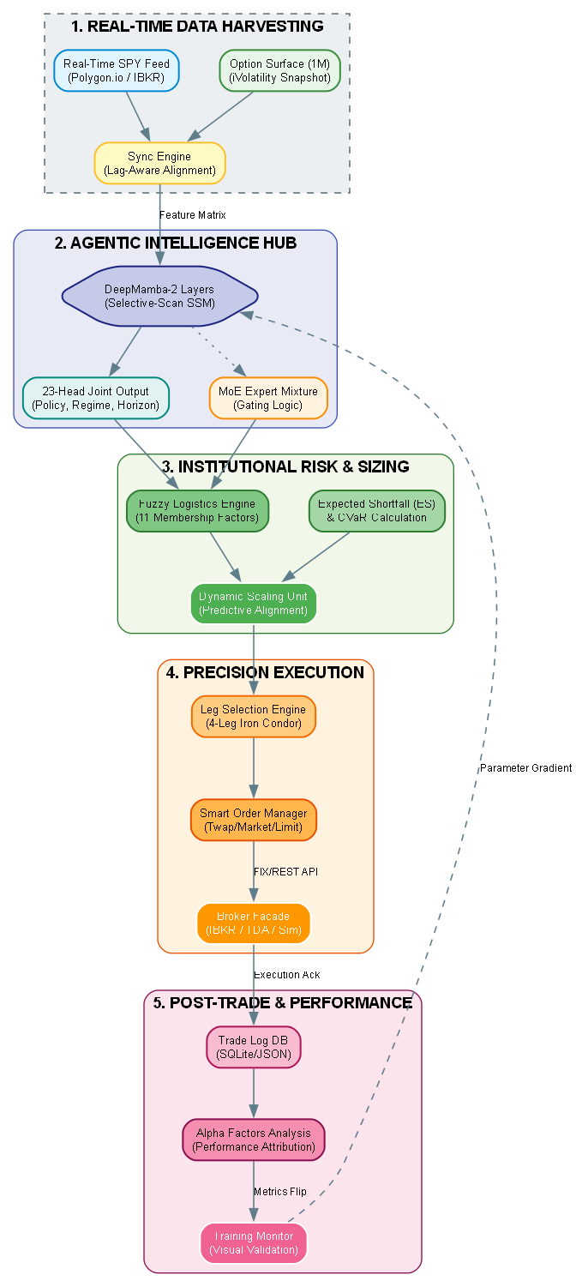

11. Impact and Velocity Assessment
The velocity achieved during the January 6–13, 2026 development window demonstrates that constraint-aware system design can dramatically compress iteration cycles without sacrificing rigor. By grounding every component in causality, alignment, and execution realism, CondorIntelligence advanced from prototype to institutional-grade benchmark in days rather than months.
For neural trading engineers, the primary contribution is not a claim of superior returns, but a reference-quality system that exposes the full chain from data latency to trade sizing. This enables meaningful comparison, critique, and extension.

Appendix A: Reproducing the Benchmark
This appendix defines the minimum requirements and procedures for reproducing CondorIntelligence as a benchmark system.

A.1 Exact Data Expectations
CondorIntelligence assumes causal, timestamped market data with explicit separation between spot and derivatives feeds.
Required Inputs:
- Spot Bars (CSV)
  - Symbols: SPY (benchmark)
  - Timeframes: 1m (required), 5m and 15m (optional but recommended)
  - Columns:
    - timestamp (UTC, tz-aware)
    - open, high, low, close, volume
- Options Chain Snapshots (CSV)
  - One snapshot per timestamp (not per bar)
  - Columns:
    - timestamp (UTC)
    - symbol
    - expiry
    - strike
    - type (C/P)
    - bid, ask
    - Greeks: delta, gamma, vega, theta
- Auxiliary Feeds (Optional but Supported)
  - VIX or IV proxy
  - Overnight gap metrics
  - ES/SPY divergence signals
All inputs are treated as potentially lagged. No assumptions of synchrony are made.

A.2 Minimal Run Path
The minimal benchmark run path is intentionally short and auditable.
- Load data
  - Memory-map CSVs
  - Construct zero-copy rolling windows
- Stream MarketSnapshot objects
  - Align spot bars with nearest valid options snapshot
  - Apply IV confidence decay and lag policies
- Neural inference
  - Pass tensors through the 24-layer Mamba-2 backbone
  - Produce 23-head joint outputs (policy, regime, horizon)
- Neural–fuzzy fusion
  - Convert neural outputs into fuzzy membership degrees
  - Aggregate into confidence and bias
- Sizing and execution decision
  - Apply volatility dampening
  - Compute final position size
  - Emit trade intent (no execution required for benchmark mode)
No broker connectivity is required to reproduce benchmark outputs.

A.3 Required Outputs to Log
The following outputs should be logged at every decision step:
- Trade Intent
  - should_trade (bool)
  - bias (bullish / neutral / bearish)
  - confidence ∈ [0, 1]
- Sizing Metrics
  - Base size
  - Volatility percentile
  - Final scaled size
- Regime Information
  - Regime probabilities (low / normal / high vol)
  - Selected expert
- Alignment Diagnostics
  - Options lag (seconds)
  - IV confidence score
  - Alignment mode (exact / prior / stale)
- Outcome Tracking (Offline)
  - Realized P&L
  - Max adverse excursion
  - Regime-conditional performance
These logs, rather than raw returns alone, form the core benchmarking surface.

Appendix B: Comparative Architecture Table
The table below summarizes key differences between common trading system paradigms and CondorIntelligence.
Dimension | Rule-Based Systems | LSTM-Based Systems | Transformer-Based Systems | CondorIntelligence (Mamba-2)
Temporal Complexity | O(1) heuristics | O(N) sequential | O(N²) attention | O(N) selective SSM
Long-Horizon Memory | Manual rules | Limited / vanishing | Strong but expensive | Strong, stable state memory
Data Lag Handling | Ad-hoc | Rarely explicit | Rarely explicit | First-class, policy-driven
Regime Awareness | Static thresholds | Implicit | Implicit | Explicit MoE gating
Trade Sizing | Fixed / Kelly | Heuristic | Heuristic | Fuzzy + volatility calibrated
Probability of Success | Implicit | Weakly inferred | Weakly inferred | Explicit confidence surface
Interpretability | High | Low | Low | Moderate–High (hybrid)
Execution Alignment | Manual | Often ignored | Often ignored | End-to-end designed
Hardware Efficiency | High | Moderate | Low–Moderate | High (GPU-linear)
Benchmark Suitability | Low | Medium | Medium | High (reference system)

Appendices A and B are intended to make CondorIntelligence directly usable as a comparative benchmark for neural trading system research and development.

